**CHAPTER– 1**

**INTRODUCTION**

* 1. **Introduction**

In the digital age, the integration of technology into various sectors has revolutionized traditional processes, enhancing efficiency, accessibility, and transparency. One such sector poised for transformation is the electoral process within academic institutions. This project aims to develop an "Online College Voting System" tailored for colleges and universities, providing a secure, user-friendly, and efficient platform for conducting student elections.

The traditional method of conducting college elections is often fraught with logistical challenges, time constraints, and security concerns. Physical voting booths require significant manpower and resources to manage, while manual vote counting can be prone to errors and manipulation. Furthermore, ensuring that all students have an equal opportunity to participate, regardless of their location or schedule, is a persistent challenge.

An online voting system harnesses the power of the internet to facilitate the voting process, making it easier for students to vote from anywhere, at any time, using their digital devices. This system not only streamlines the administrative process of organizing elections but also ensures greater accuracy in vote counting and result tabulation.

It delves into the technical aspects of the system, including its architecture, security features, and user interface design. Furthermore, the report examines the benefits and potential challenges associated with the adoption of such a system, supported by case studies and statistical data from institutions that have successfully implemented online voting.

The Online College Voting System seeks to address these issues by leveraging modern web technologies to create a streamlined, accessible, and secure voting platform. This system will allow students to cast their votes from any location with internet access, ensuring greater participation and inclusivity. By incorporating robust authentication mechanisms and data encryption, the system will safeguard the integrity and confidentiality of the voting process.

**1.2 Problem Statement**

In recent years, college elections have become a vital aspect of campus life, fostering student engagement and promoting democratic values within academic institutions. However, traditional voting methods employed in these elections face numerous challenges that hinder their effectiveness and inclusiveness. The logistical complexities of organizing physical voting booths, managing paper ballots, and coordinating election personnel demand substantial time, effort, and financial resources. These hurdles often lead to delays, increased costs, and administrative inefficiencies. Moreover, the requirement for students to vote at specific locations and times contributes to low voter turnout, as many students find it inconvenient to participate due to conflicting class schedules, off-campus commitments, or personal reasons. This situation is further exacerbated for students with disabilities, who may face significant barriers in accessing voting facilities, thereby limiting their ability to engage in the electoral process fully.

Security concerns also pose a major challenge to traditional voting systems. Issues such as ballot tampering, unauthorized access to voting materials, and inaccuracies in vote counting undermine the integrity and confidentiality of the elections, leading to potential disputes and a lack of trust in the results. Manual vote counting, while common, is labor-intensive and prone to human error, which can compromise the accuracy and reliability of the election outcomes. These challenges highlight the urgent need for a more efficient, secure, and accessible voting solution that can address the limitations of traditional methods.

An online voting system for college elections can streamline the process, allowing students to vote from anywhere using their devices. This approach reduces logistical and financial burdens, enhances vote counting accuracy and speed, and employs encryption and secure authentication to protect the integrity and confidentiality of the voting process.

In conclusion, implementing an online voting system for college elections is essential to address the inefficiencies, security concerns, and accessibility issues of traditional methods. This system aims to create a more effective, transparent, and inclusive electoral process, enhancing the democratic experience for the student body and ensuring representative elections.

**1.3 Objective**

The primary objective of developing and implementing an online voting system for college elections is to create a streamlined, secure, and accessible platform that enhances the overall electoral process, ensuring that it is efficient, transparent, and inclusive. This objective encompasses several key goals aimed at addressing the limitations and challenges inherent in traditional voting methods. Firstly, the system seeks to significantly reduce logistical complexities by eliminating the need for physical voting booths and paper ballots, thereby saving time, effort, and financial resources. This will facilitate a more organized and cost-effective administration of elections. Secondly, the online voting system aims to increase voter turnout by providing students with the convenience of casting their votes from any location, at any time, using their digital devices. This flexibility will accommodate students' diverse schedules and commitments, encouraging broader participation and engagement in the democratic process.

Moreover, the objective includes enhancing the security and integrity of the voting process. By incorporating advanced security features such as encryption, secure authentication protocols, and blockchain technology, the online system will protect against threats like ballot tampering, unauthorized access, and vote manipulation. These measures will ensure that the election results are accurate, reliable, and free from fraud, thereby fostering trust and confidence among the student body. The online voting system also aims to provide an intuitive and user-friendly interface that makes the voting process straightforward and accessible for all students, including those with disabilities or those studying remotely. This inclusivity is crucial for ensuring that every student has an equal opportunity to participate in college elections, reflecting a truly representative and democratic outcome.

Additionally, the system seeks to automate the vote counting and result tabulation processes, reducing the risk of human error and expediting the delivery of election results. This will not only enhance the accuracy of the outcomes but also improve the transparency of the election process, as students can be assured of the integrity and promptness of the results. The objective further extends to ensuring that the online voting system is scalable and adaptable, capable of accommodating various types of elections and evolving to meet future technological advancements and changing student needs.

**1.4 Scope of the project**

The scope of the project on developing an online college voting system encryption-based authentication encompasses the design, development, implementation, and evaluation of a comprehensive digital platform aimed at modernizing the electoral process within academic institutions. This project will involve several key phases, starting with the identification and analysis of the requirements and challenges associated with traditional voting methods. The system will be designed to address these challenges by providing a secure, user-friendly, and accessible interface that enables students to cast their votes electronically from any location using various digital devices. The development phase will include the creation of the system architecture, integrating robust security measures such as encryption, secure authentication, and blockchain technology to ensure the integrity and confidentiality of the voting process. Additionally, the project will involve the creation of an administrative backend to manage election setup, candidate registration, and real-time monitoring of the voting process.

The scope also includes extensive testing to ensure the system's reliability, usability, and security, with particular attention to safeguarding against potential cyber threats and ensuring compliance with data protection regulations. User training and support materials will be developed to assist students and election administrators in navigating the new system effectively. The implementation phase will see the deployment of the system in a controlled environment, followed by a pilot run to gather feedback and make necessary adjustments. Finally, the project will encompass the full-scale rollout of the online voting system across the college, accompanied by continuous monitoring and periodic updates to address any emerging issues and incorporate new features.

Furthermore, the project scope includes conducting a thorough evaluation of the system's impact on voter turnout, election integrity, and overall student engagement. This will involve collecting and analyzing data to assess the effectiveness of the online voting system in meeting its objectives and providing recommendations for future improvements. By covering these comprehensive aspects, the project aims to deliver a robust, efficient, and inclusive online voting system that enhances the democratic experience for the college community and sets a precedent for modernizing electoral processes in academic settings.

**CHAPTER – 2**

**LITERATURE SURVEY**

**2.1.Existing System**

The existing voting system in college elections typically relies on traditional methods, including paper ballots and physical voting booths, which have been the cornerstone of electoral processes for decades. This system involves a series of manual and logistical tasks starting with the preparation and distribution of paper ballots, setting up voting stations at designated locations across the campus, and employing staff or volunteers to oversee the voting process and ensure its integrity. On election day, students are required to physically go to these voting stations during specific hours, present their identification, and cast their votes by marking their choices on paper ballots. These ballots are then collected and securely stored until the voting period concludes. Following the closure of the polls, the labor-intensive process of counting the votes begins, typically conducted by election officials or volunteers under strict supervision to prevent tampering or errors. Despite its widespread use, this traditional system faces several significant challenges that affect its efficiency and reliability.

One of the primary issues with the existing voting system is logistical complexity. Organizing and managing physical voting booths require significant resources, including time, labor, and financial investment. Setting up voting stations, printing ballots, and coordinating election staff can be cumbersome and costly. Additionally, the process of manually counting votes is not only time-consuming but also prone to human error, which can lead to inaccuracies and disputes over the results. Security concerns also pose a critical challenge, as traditional voting methods are susceptible to ballot tampering, unauthorized access, and other forms of electoral fraud, compromising the integrity of the elections. Another major drawback is the inconvenience posed to students, who must be physically present at specific locations during limited voting hours. This often results in low voter turnout, as students with busy schedules, off-campus commitments, or accessibility issues may find it difficult to participate in the voting process. Moreover, students with disabilities or those studying remotely face additional barriers that further hinder their ability to vote, thereby reducing the inclusivity and representativeness of the election outcomes.In conclusion, while the existing traditional voting system has been a longstanding method for conducting college elections,

it is fraught with challenges related to logistics, security, voter turnout, and accessibility. These issues highlight the need for a more modern and efficient solution that can

streamline the voting process, enhance security, and ensure greater participation from the student body. Addressing these limitations is crucial for fostering a more democratic and inclusive electoral environment within academic institutions.

**2.2 Limitations of Existing System**

The existing voting system in college elections, predominantly reliant on traditional methods such as paper ballots and physical voting booths, presents several significant limitations that impede the efficiency, security, and inclusiveness of the electoral process. One of the foremost limitations is the logistical complexity involved in organizing and conducting elections. Setting up voting stations across the campus, printing and distributing paper ballots, and coordinating election personnel demand considerable time, effort, and financial resources. These logistical challenges often lead to delays, increased costs, and administrative inefficiencies, making the process cumbersome and resource-intensive. Another critical limitation is the low voter turnout typically observed in college elections. The requirement for students to vote in person at specific locations and during limited hours often conflicts with their academic schedules, extracurricular activities, and personal commitments, discouraging participation. This issue is further exacerbated for students with disabilities or those studying remotely, who may face additional barriers in accessing voting facilities, thereby diminishing the inclusiveness of the election process.

Security concerns also plague the traditional voting system. The susceptibility to ballot tampering, unauthorized access to voting materials, and potential manipulation during manual vote counting compromise the integrity and confidentiality of the elections. Ensuring the security of paper ballots throughout the process is challenging, and the reliance on human oversight increases the risk of errors and fraud. The manual vote counting process itself is labor-intensive and prone to human error, which can lead to inaccuracies in the results and subsequent disputes. These errors not only undermine the reliability of the election outcomes but also erode trust in the electoral process among the student body. Additionally, the traditional system lacks transparency and real-time feedback mechanisms, making it difficult for students to verify the integrity of the process and the accuracy of the results.

Moreover, the traditional voting system is not environmentally sustainable due to the significant amount of paper waste generated from printing ballots and other election materials. The physical nature of the system also limits its scalability and adaptability to handle various types of elections or accommodate a larger student population. In summary, the existing voting system in college elections is fraught with limitations related to logistical inefficiencies, low voter turnout, security vulnerabilities, and environmental sustainability. These challenges underscore the need for a modern, digital solution that can streamline the voting process, enhance security, increase participation, and ensure a more inclusive and transparent electoral system within academic institutions.

**2.3 Proposed System**

The adoption of an online college voting system represents a transformative shift from traditional, paper-based voting methods to a modern, digital platform that offers numerous advantages for academic institutions. One of the primary benefits is enhanced accessibility and convenience. Unlike traditional voting systems that require students to physically visit designated polling stations during specific hours, an online voting system allows voters to cast their ballots from anywhere and at any time using their digital devices, such as smartphones or computers. This flexibility accommodates busy student schedules, varying time zones, and accessibility needs, thereby significantly increasing voter turnout and engagement in the electoral process.

Moreover, an online voting system improves efficiency by automating key processes that are traditionally labor-intensive and time-consuming. Tasks such as voter registration, ballot distribution, and vote counting are streamlined through digital interfaces, reducing administrative workload and ensuring faster, more accurate election results. This efficiency not only saves resources but also enhances the overall transparency and integrity of the electoral process.

Security is another critical advantage of online voting systems. Advanced encryption techniques, secure authentication protocols, and robust data protection measures safeguard the integrity and confidentiality of each vote cast. Unlike paper-based systems susceptible to ballot tampering or mishandling, online platforms offer built-in safeguards against fraud and unauthorized access, ensuring that each vote is securely recorded and counted.

Furthermore, online voting systems promote environmental sustainability by significantly reducing paper usage and waste associated with traditional voting methods. This aligns with institutional goals of reducing carbon footprints and promoting eco-friendly practices within academic environments.

Additionally, the real-time accessibility of election results and analytics provides immediate feedback to students and election administrators, fostering transparency and accountability in the electoral process. Voters can verify their ballots and participation instantly, enhancing trust in the system's fairness and accuracy.

**CHAPTER– 3**

**SYSTEM REQUIREMENTS SPECIFICATION**

**3.1 Specific Requirements**

3.1.1 Hardware Requirements

* + **CPU 10 - 12th generation**
  + A computer to run the XAMPP server.
  + Recommended specifications: Intel i5 or above processor, 8GB RAM or higher, SSD with at least 100GB storage.
* **Client Devices**:
  + Computers or mobile devices with internet access for students to vote.

#### 3.1.2 Software Requirements

* **Server-side**:
  + XAMPP (Apache, MySQL, PHP)
  + PHP 7.4 or above.
* **Client-side**:
  + Modern web browser (Chrome, Firefox, Safari)
  + HTML, CSS, JavaScript support.
* **Development Tools**:
  + **VS Code**: Primary IDE for developing both frontend and backend.
  + **Extensions**: Live Server, Prettier, PHP Intelephense, MySQL.

#### 3.1.3 Functional Requirements

* **User Authentication**: Secure login for students.
* **Voting Process**:
  + Select candidates
  + Submit vote
  + Confirm vote submission
* **Vote Counting**: Real-time update of election results.
* **Admin Panel**: Manage elections, view results, handle user queries.

#### 3.1.4 Non-functional Requirements

* **Performance**: Fast response time for voting and result updates.
* **Scalability**: Support for a large number of concurrent users.
* **Security**: Hashing-based authentication for user data protection.
* **Usability**: Intuitive interface for ease of use.
* **Compatibility**: Cross-device and cross-browser compatibility.

**3.2 System Design**

#### 3.2.1 Hardware Requirements

* **Server Specifications**:
  + Processor: Intel i5 or above to handle multiple requests simultaneously.
  + RAM: At least 8GB to ensure smooth operation and quick response times.
  + Storage: SSD with at least 100GB to store the database and application files.
* **Client Specifications**:
  + Any modern device (PC, laptop, smartphone, tablet) with internet access.
  + Devices should have modern web browsers installed.

#### 3.2.2 Software Requirements

* **Server-side**:
  + XAMPP (latest version with Apache, MySQL, PHP)
  + Operating System: Compatible with Windows 10, Linux, or MacOS.
* **Client-side**:
  + Modern web browsers such as the latest versions of Chrome, Firefox, or Safari.
  + Basic web technologies: HTML5 for structure, CSS3 for styling, and JavaScript ES6 for interactivity.
* **Development Tools**:
  + **VS Code**: Integrated development environment for both frontend and backend development.
  + **Extensions**: Live Server, Prettier, ESLint, PHP Intelephense, MySQL.

#### 3.2.3 Functional Requirements

* **Authentication System**:
  + Secure login/logout functionality.
  + Password hashing and validation using algorithms like bcrypt.
* **Voting Interface**:
  + Display a list of candidates in a clear and organized manner.
  + Allow students to select candidates and submit their votes via a simple form.
* **Vote Management**:
  + Record votes in the database, ensuring data integrity.
  + Prevent duplicate voting by validating user submissions.
* **Result Display**:
  + Update results in real-time and display them to users.
  + Provide graphical representations (charts/graphs) for better understanding.
* **Admin Interface**:
  + Tools for creating and managing elections, including setting up candidates and voting periods.
  + View and download detailed election results and statistics.
  + Manage user accounts, including adding or removing users.

#### 3.2.4 Non-functional Requirements

* **Performance**:
  + Optimize server response times through efficient coding practices and database indexing.
  + Implement caching to reduce server load and improve speed.
* **Scalability**:
  + Design the system to handle a large number of concurrent users, using techniques such as load balancing.
  + Plan for future growth and scalability by considering cloud solutions if necessary.
* **Usability**:
  + Design an intuitive interface with clear instructions and easy navigation.
  + Ensure accessibility for users with disabilities by incorporating features like screen reader compatibility and keyboard navigation.
* **Compatibility**:
  + Test the website across various devices and browsers to ensure consistent functionality.
  + Regularly update the system to maintain compatibility with new technologies and browser versions.

**CHAPTER-4**

**SYSTEM DESIGN**

**4.1 Block Diagram**

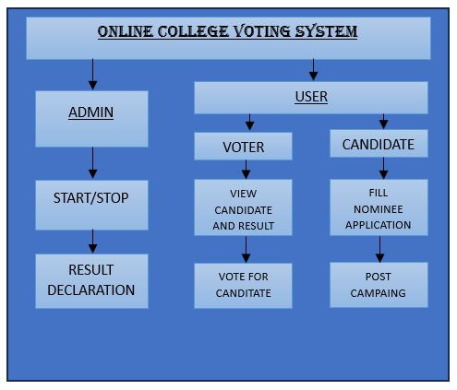

**Figure 1**: System Block Diagram of the College Voting System

The “Online College Voting System” the roles and actions of the admin, voters, and candidates. The admin has the authority to start and stop the voting process and declare the results once voting is complete. Users are categorized into voters and candidates. Voters can view the candidates and election results, and they cast their votes for their preferred candidates. Candidates, on the other hand, must fill out a nominee application to participate in the election and can post campaign materials to engage with voters. This system ensures a structured and organized approach to managing college elections online.

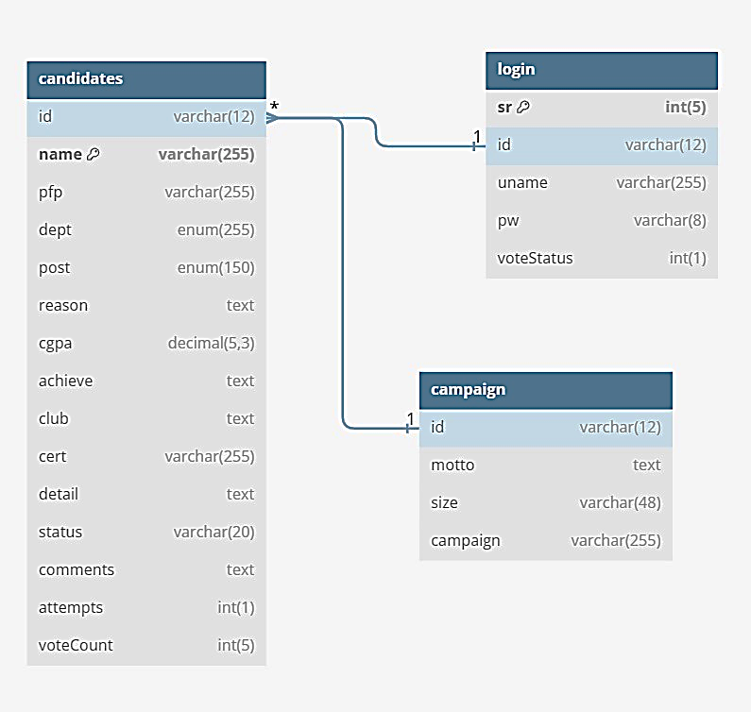 **4.2 Entity Relationship Diagram**

|  |
| --- |
|  |

**4.3 Wireframes**

### Login Page

* **Elements**: User ID field, Password field, Login button.
* **Interactions**: Users enter their credentials to log in.

### Candidate Details Page

* **Elements**: List of candidates, candidate details.
* **Interactions**: Users view information about each candidate.

### Voting Page

* **Elements**: Voting options, Submit Vote button.
* **Interactions**: Users select their preferred candidates and submit their votes.

### Admin Panel

* **Elements**: Start/Stop election buttons, Result declaration button, User management controls.
* **Interactions**: Admins manage the election process and user accounts.

**CHAPTER-5**

**IMPLEMENTATION**

**// Submit Vote and Encryption**

<?php

if (isset($_POST['submitVote'])) {

$updateVoteFlag = "UPDATE login SET voteStatus=1 WHERE id=?";

$stmt = mysqli_prepare($conn, $updateVoteFlag);

mysqli_stmt_bind_param($stmt, 's', $_SESSION['id']);

$result = mysqli_stmt_execute($stmt);

function encrypt($data, $key) {

$iv = openssl_random_pseudo_bytes(openssl_cipher_iv_length('aes-256-cbc'));

$encrypted = openssl_encrypt($data, 'aes-256-cbc', $key, 0, $iv);

return base64_encode($encrypted . '::' . $iv);

}

// Add Vote count

foreach ($_POST as $key => $value) {

if ($key != 'submitVote') {

$query = "SELECT voteCount FROM candidates WHERE id = ?";

$stmt = mysqli_prepare($conn, $query);

mysqli_stmt_bind_param($stmt, 's', $value);

mysqli_stmt_execute($stmt);

mysqli_stmt_bind_result($stmt, $currentVoteCount);

mysqli_stmt_fetch($stmt);

mysqli_stmt_close($stmt);

if ($currentVoteCount !== null) {

// Decrypt current vote count

list($encrypted_data, $iv) = explode('::', base64_decode($currentVoteCount), 2);

$decryptedVoteCount = openssl_decrypt($encrypted_data, 'aes-256-cbc',

ENCRYPTION_KEY, 0, $iv);

// Increment vote count

$newVoteCount = (int)$decryptedVoteCount + 1;

} else {

$newVoteCount = 1;

}

// Encrypt updated vote count

$encryptedVoteCount = encrypt($newVoteCount, ENCRYPTION_KEY);

// Update encrypted vote count to database

$query = "UPDATE candidates SET voteCount = ? WHERE id = ?";

$stmt = mysqli_prepare($conn, $query);

mysqli_stmt_bind_param($stmt, 'ss', $encryptedVoteCount, $value);

$result = mysqli_stmt_execute($stmt);

if ($result) {

echo "Vote for nominee with id $value updated successfully.<br>";

} else {

echo "Error updating vote for nominee with id $value: " . mysqli_error($conn) . "<br>";

}

mysqli_stmt_close($stmt);

}

}

header("Location:../users/successVote.php");

exit();

}

?>

<?php

}

// Election status and display result

<head>

<script src="https://cdn.canvasjs.com/canvasjs.min.js"></script>

</head>

<body>

<?php

require '../common/connect.php';

define('ENCRYPTION_KEY', getenv('ENCRYPTION_KEY'));

if ($_SESSION['id'] == 'admin') {

$query = "SELECT voteStatus FROM `login` WHERE id='admin'";

$result = mysqli_query($conn, $query);

while ($admin = mysqli_fetch_assoc($result)) {

// Start Voting

if($admin['voteStatus']==0){

?>

<?php

}

// Declare Voting Results

else if($admin['voteStatus']==2){

?>

<form action="../common/voteActions.php" method="post" class="w-100 text-center my-5">

<button type="button" class="btn btn-info" data-bs-toggle="modal" data-bs- target="#declareResults">Declare Results</button>

<div class="modal fade" id="declareResults" data-bs-backdrop="static" data-bs-keyboard="false" tabindex="-1" aria-labelledby="declareResultsLabel" aria-hidden="true">

<div class="modal-dialog">

<div class="modal-content">

<div class="modal-header">

<h1 class="modal-title fs-5" id="declareResultsLabel">Confirm Declare Results</h1>

<button type="button" class="btn-close" data-bs-dismiss="modal" aria-label="Close"></button>

</div>

<div class="modal-body">

All votes will be counted and results will be displayed!

</div>

<div class="modal-footer">

<button type="button" class="btn btn-secondary" data-bs- dismiss="modal">Close</button>

<button type="submit" class="btn btn-info" name="declareResults">Declare Results</button>

</div>

</div>

</div>

</div>

</form>

<?php

<?php

}

echo "<h1 class='text-center mt-5'>Election Stats</h1>";

function displayChart($position, $postID, $conn)

{

$voteChart = array();

$count = 0;

$vote = "SELECT * FROM candidates WHERE status='Accepted' AND post='$position'";

$result = mysqli_query($conn, $vote);

while ($row = mysqli_fetch_assoc($result)) {

// Decrypt the vote count

$encrypted_data = base64_decode($row['voteCount']);

$parts = explode('::', $encrypted_data);

if(count($parts) === 2) {

list($encryptedVoteCount, $iv) = $parts;

$decryptedVoteCount = openssl_decrypt($encryptedVoteCount, 'aes-256-cbc', ENCRYPTION_KEY, 0, $iv);

} else {

$decryptedVoteCount = 'Error: Invalid encryption data';

}

$voteChart[$count]["label"] = $row["name"];

$voteChart[$count]["y"] = (int)$decryptedVoteCount;

$count++;

}

?>

<div id="chartContainer<?= $postID ?>" style="height: 500px; width: 100%;"></div>

<script>

var chart<?= $postID ?> = new CanvasJS.Chart("chartContainer<?= $postID ?>", {

animationEnabled: true,

theme: "light2",

title: {

text: "<?= $position ?>"

},

axisY: {

title: "Vote Count"

},

data: [{

type: "column",

yValueFormatString: "#,##0 votes",

dataPoints: <?php echo json_encode($voteChart, JSON_NUMERIC_CHECK); ?>

}]

});

chart<?= $postID ?>.render();

</script>

**CHAPTER-6**

**TESTING**

|  |  |  |  |  |
| --- | --- | --- | --- | --- |
| **S.No** | **Test Case Description** | **Preconditions** | **Expected Result** | **Status** |
| 1 | Admin Login | Admin account exists | Admin dashboard is displayed | [Pass/Fail] |
| 2 | Start Voting Process | Admin logged in | Voting process is initiated | [Pass/Fail] |
| 3 | Stop Voting Process | Voting process started | Voting process is terminated | [Pass/Fail] |
| 4 | Result Declaration | Voting process stopped | Election results are displayed | [Pass/Fail] |
| 5 | Voter Login | Voter account exists | Voter dashboard is displayed | [Pass/Fail] |
| 6 | View Candidates and Results | Voter logged in | List of candidates and election results are displayed | [Pass/Fail] |
| 7 | Vote for Candidate | Voting period active | Vote is successfully cast | [Pass/Fail] |

**CHAPTER-7**

**RESULTS AND SNAPSHOTS**

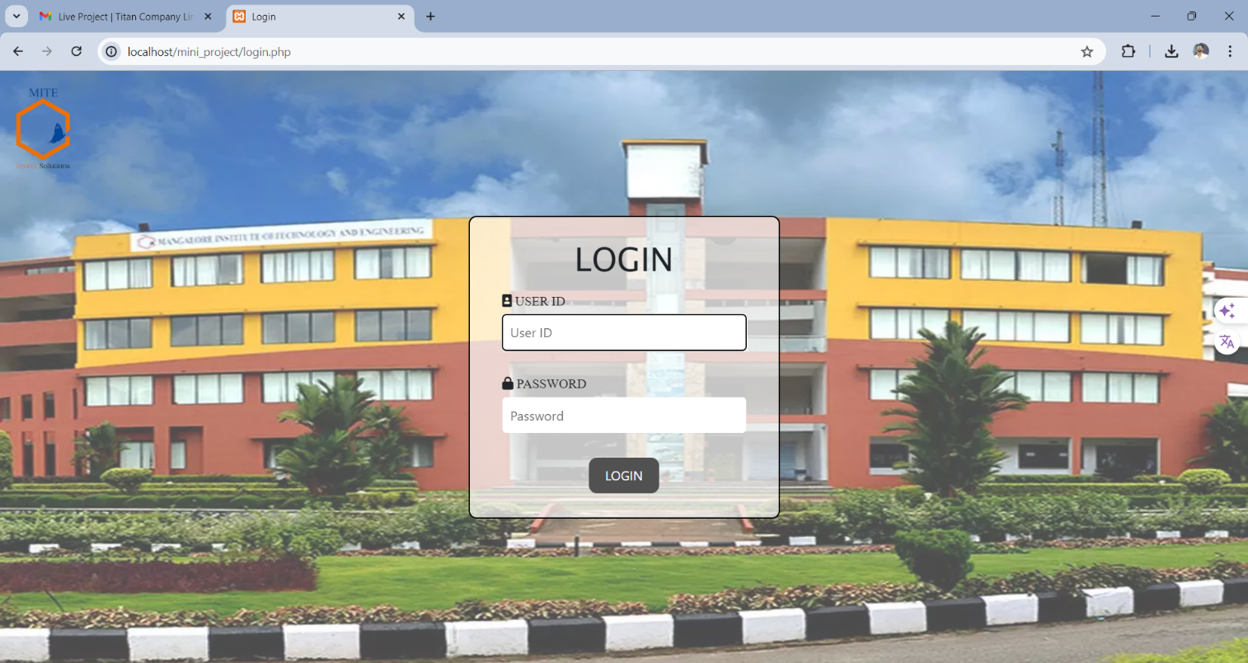

**Fig:7.1 Login page**



**Fig:7.2 Candidate and Voter page**

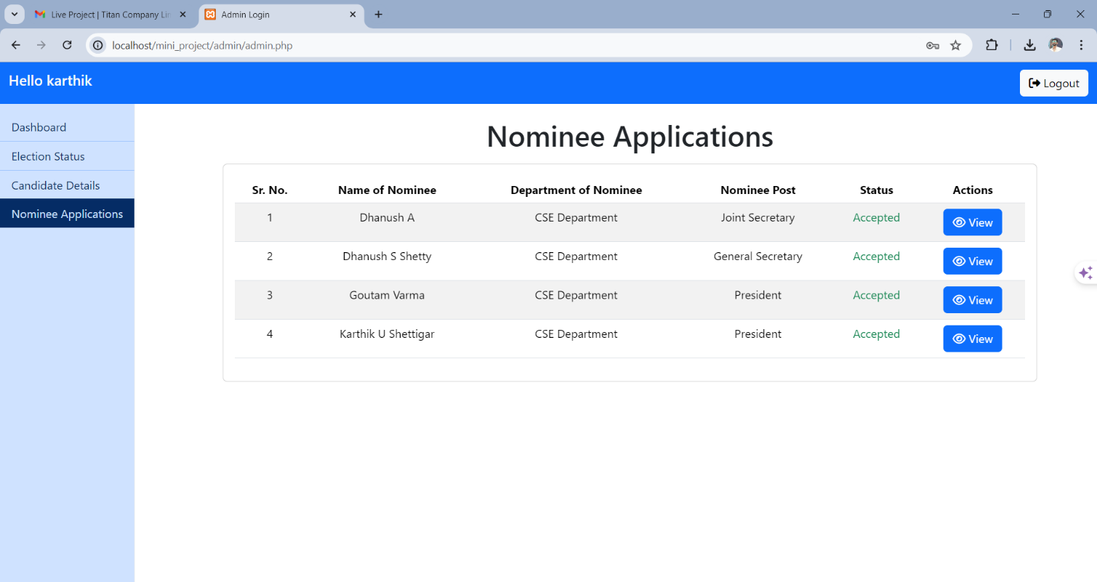

**Fig: 7.3 Nominee details**

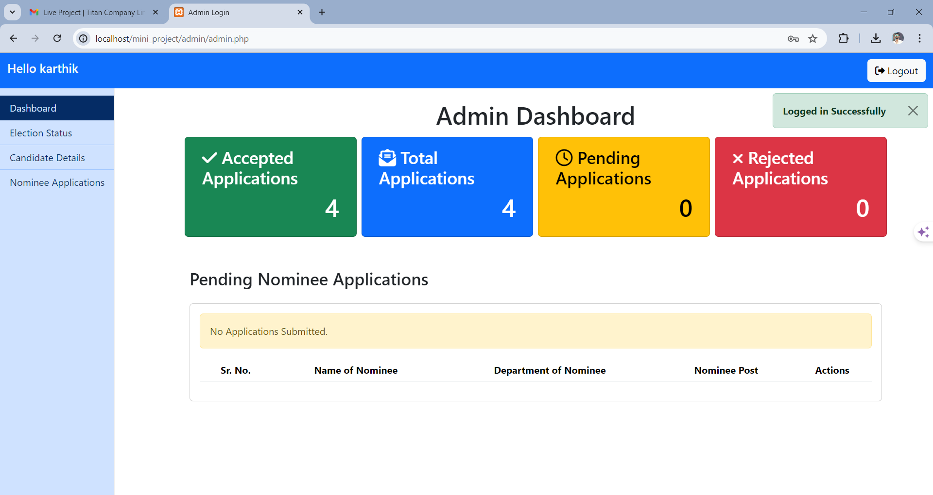

**Fig:7.4 Admin Dashboard**

**CHAPTER -8**

**CONCLUSION AND FUTURE WORK**

**8.1 Conclusion**

The primary objective of the Online College Voting System is to provide a user-friendly and easily accessible platform for voters to exercise their democratic right through the internet. The implementation of basic security measures has provided a secure environment for casting and counting votes, minimizing the risk of fraud and manipulation. Overall, this system represents a significant step forward in modernizing the electoral process within educational institutions.

**8.2 Future Work**

In future iterations, the Online College Voting System aims to integrate advanced security features to further bolster the integrity and confidentiality of the voting process. Additionally, the potential inclusion of Blockchain technology will be explored. Blockchain can provide a decentralized and immutable ledger, making the voting process even more transparent and tamper-proof. By leveraging these technologies, the system will achieve higher levels of security, reliability, and trust among its users, setting a new standard for digital voting systems in educational settings.

**REFERENCES**

[1] Fatima Zahrae Chentouf, Said Bouchkaren “Security and privacy in smart city: A secure e-voting system based on blockchain”, ERMIA Team, Department of Computer Science,ENSAT, Abdelmalek Essaadi University, Vol. 13, No. 2, April 2023,pp. 1848~1857 ISSN: 2088-8708, DOI: 10.11591/ijece.v13i2.pp1848-1857.

[2] K. P. Kaliyamurthie, R. Udayakumar, D. Parameswari and S.N. Mugunthan “Highly Secured Online Voting System over Network”, Deptartment of IT, Bharath University, Chennai,Jerusalem College of Engineering, Chennai, Vol 6 (6S) | May 2013.

[3] Ankit Anand, Pallavi Divya “An Efficient Online Voting System”, Department of Computer Science Engineering, BITSBhopal/ Rajiv Gandhi Technical University, Vol.2, Issue.4, July-Aug.2012 pp-2631-2634.

[4] Hind S. Hassan, Rehab Hassan, Ekhlas K. Gbashi “E-voting System Based on Ethereum Blockchain Technology Using Ganache and Remix Environments”, Computer Science Dept.,University of Technology-Iraq, Journal 4SSS1 (04) (2023) 562- 577.